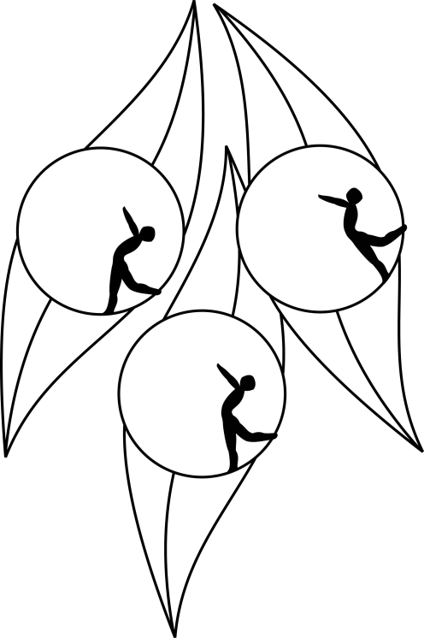
SOUTH AUSTRALIAN ICE SKATING ASSOCIATION Inc.

Results

TEST SESSION

7 November 2010
Ice Arena, Thebarton

Congratulations to the following skaters:

Pre-Primary Technical
Alessandra Triulcio

Pre-Primary Figure Pattern
Sakura Conlon

Elementary
Elysha Glaser
Aidon-Reece Michalowski

Elementary Technical
James Sothea Min

Preliminary
Callum Bradshaw
Kiana Castro
Maddison Schmidt

